**Test plan and Expected output:-**

1. Insert movie
2. View all movie
3. Find movie
4. Book movie
5. Fill details
6. Exit

**EXPECTED RESULTS**

|  |  |  |
| --- | --- | --- |
| Enter your choice: 1 | Insert movie | Enter movie code :- 21  Enter  name :- fidda  Enter Release Date:25/09/2020  Enter Ticket Price:- 150  Record insert Successful |
| Enter your choice:2 | View all movie | 21 fidda 25/09/2020  150 |
| Enter your choice:3 | Find Movie | Enter movie code :21  Record Found   Code :21   movie name :fidda   movie date :25/09/2020    price of ticket :150 |
| Enter your choice: 4 | Book Ticket | 21 fidda 25/10/2020 250  Enter movie code :21   Record Found    Code ::21    Movie name ::fidda    date name ::25/09/2020  Price of ticket::150 |
| Enter your choice:5 | Fill Details | your name :mounika   mobile number :8123568658   Total number of tickets :4   ***** ENJOY MOVIE ****   name : mounika    mobile Number : -8123568658     movie name : fidda     Total seats : 4     cost per ticket : 250    Total Amount : 1000 |

**OUTPUT**

1. Enter a number between 1 to 5

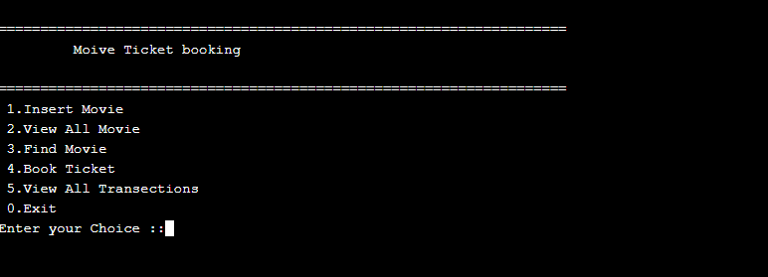

1. Insert movie details

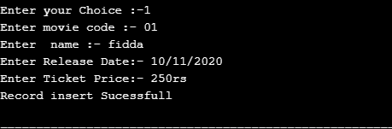

1. It shows the details of all movies

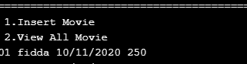

4.find the details of particular movie

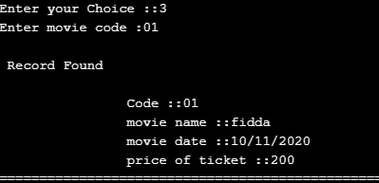

5.fill the details of customer and book the ticket.

